

|  |  |
| --- | --- |
| Course name | Emerging Digital Culture |
| Course code | COMM2746 |
| Lecturer | Chau Tran-Vi |
| Subject name | Assignment 1: Essay on Internet Art |
| Student name | Ho Duc Duy |
| Student sID | S4052522 |
| Word count |  |

Essay on Internet art - The File Room

According to Net Art Anthology (n.d.), The File Room is a temporary physical installation and an open-ended online database where records of past cases of censorship throughout history and from different cultures are restored. It was created by a Spanish artist, Antoni Muntadas and other collaborators, and it is hosted by Randolph Street Gallery (RSG) via servers in Chicago and New York from 1994 to 2016. The File Room’s main mission was to create an extensive archive that classify instances of forgotten or deleted censorship to reintroduce back into the public record. Visitors could also add their own instances of cultural and artistic censorship to an open-ended archive with just a few clicks. The data has now been saved in Rhizome restoration.

The File Room was created in a poor situation, when it had to face its own problems of inclusion and access. At that time, internet was only available among the government and university levels, and maneuvering a high barrier of technological savviness was required to access.

By containing numerous records of cultural and artistic material and let people add their own instances, The File Room allows the society to freely access to a huge database for any purposes under several context such as political thought, historical events and so on. Dietz (2002) states that The File Room represents for the fifth dream of technology, which is the Dream of Transparency. The author mentions that lack of transparency is the main cause of communication issues and it is said to be an initiator in solving this problem by allowing people to access to a huge database and post comments or information with Internet connection. Moreover, it is not only an artwork but also a visually special and a proto-example of net installation for open access in the Internet-integration era and physical interaction modalities for the artist specifies.

The File Room website took more than 2 years to complete. Muntadas and his collaborators decide to use a web browser of NCSA Mosaic which provide them with customization and kiosk-mode version for searching terms or sorting by category and location (Rhizome n.d.). Most uniquely, “The File Room” did not provide information in encyclopedic form like Wikipedia. Instead, it used the form of the database to highlight the debated nature of culture and knowledge. Its core ability is to browse, search and add records to a database censorship cases using IIS Window Server 2003 with Adobe ColdFusion (Rhizome n.d.).

My feeling when first experiencing The File Room (TFR) was very supprising and impressed. According to Bartolo (2016), TFR is the first artwork in the world to have a database which allows people to access digital archives. As i know that from 1994, there was no artwork that have database for archives of past records so that is why it impressed me a lot. I was also curious about the drawers loaded full around the room and i wonder what types of information were stored in them.

When accessed The File Room website’s homepage, apart from the old, out-of-dated website interface, I was attracted by a large image with a headline that somehow clearly conveys the primary purpose and a call-to-action button. The menu bar above with icons designed in minimalism style which made it easier for visitors to understand their functions **(Figure 1)**. Unfortunately, there were no sound effects at all and the loading speed of the page was quite slow.

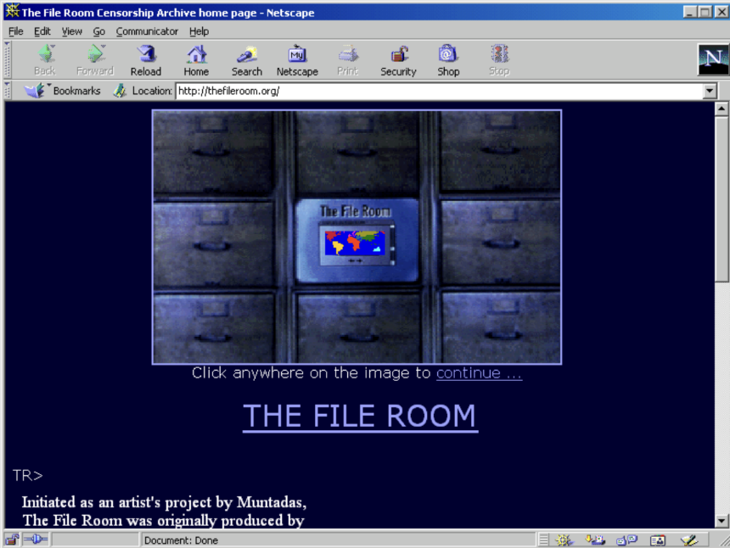

Figure 1: Homepage of The File Room website

Then, i clicked on the image laid at the center of the website and it directed me to an list of options called “Table of Contents” **(Figure 2)**. I wonder how they can create such a detailed and interactable artwork like this.

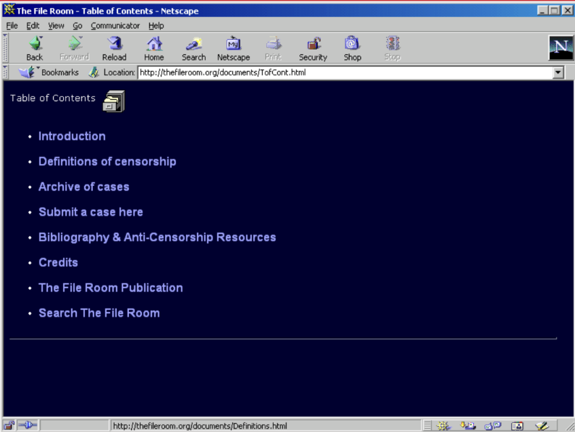

Figure 2: The list of options of The File Room.

I randomly accessed to the function called “Submit a case here” and there were a list detail section blanks pop up to fill in cases along with a short instruction **(Figure 3)**. After filled all information in, I can either clicked “Submit case” to complete my submission or “Cancel” to be taken back to the menu list or “Clear” to delete all my filled information **(Figure 4)**.

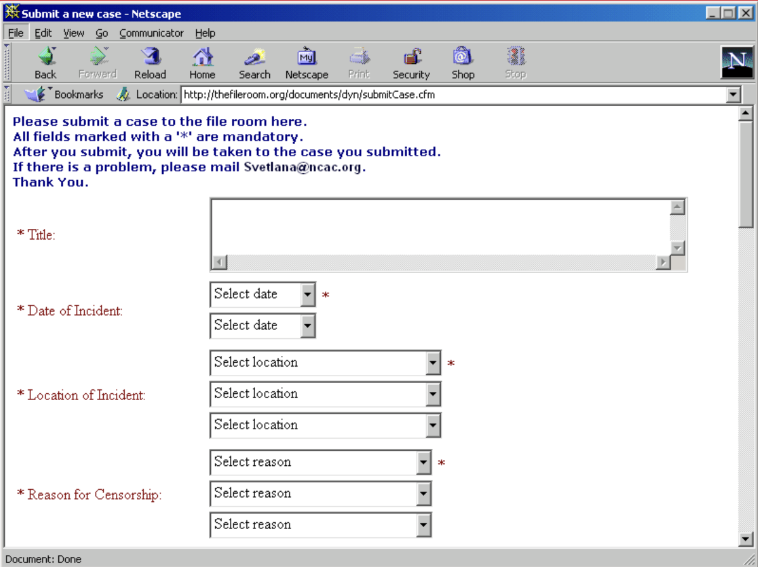

Figure 3: Interface of case submitting function in The File Room.

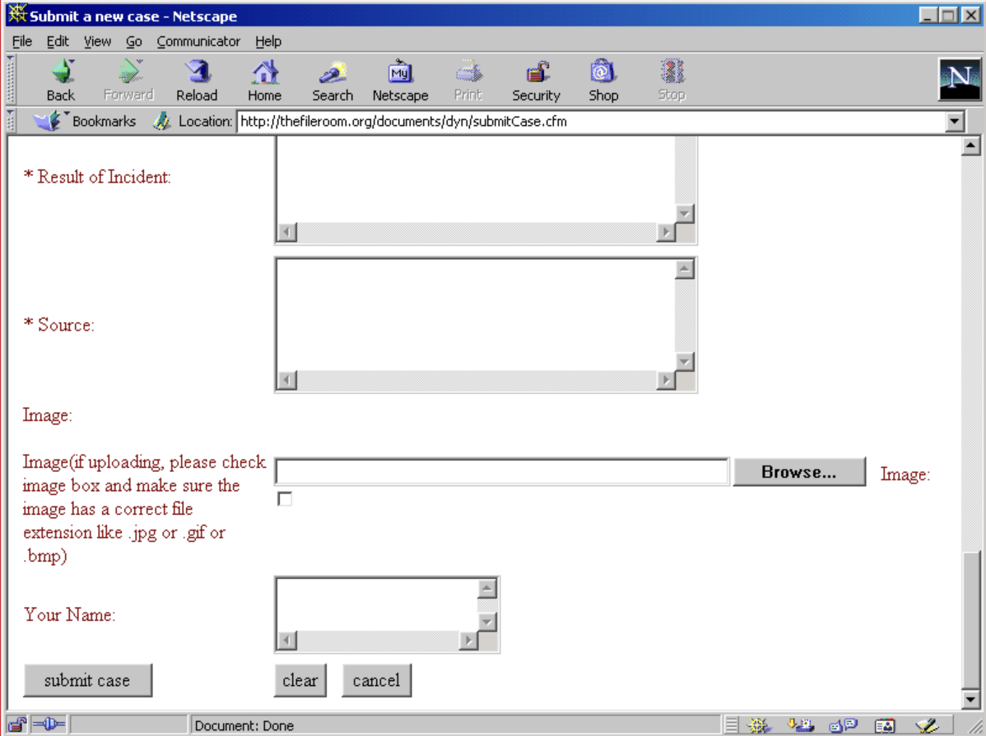



Figure 4: Options to choose wether to submit, clear all text or cancel the submission.

Interacting with The File Room, in short, made me curious about history censorship cases as well as excited when I could able to contribute to a public artwork.

Just like other artworks, The File Room also has its unique qualities. Interactive installation is one of those. The File Room is not a passive artwork but an immersive one. To be more specific, Visitors can explore and engage with the contents in a massive archive of documents. Another distinctive point is its critical engagement with power. Muntada’s works often addresses issues of power and control, and The File Room is not an exception. Last but not least, instead of offering a definitive interpretation, it encourages visitors to contribute their own narratives from the vast array of materials. This open-ended method does enhance critical thinking dialogue.

An artwork that is similar to The File Room could be Netart Latino Database (NLD) created by an Uruguayan artist Brian Mackern. Both projects did have some similarities in terms of nature and context. Both TFR and NLD were originately an archive as well as an artwork, and they were created in the early stage of the internet when accessibility was limited. However, instead of containing all types of global-scale censorship information, NLD mainly focus on Latin American artworks. Regarding the technological aspect, Mackern used ASCII art-a digital practice in which images are created using text characters (Net Art Anthology n.d.) for his website compared to the NCSA Mosaic with customization and kiosk-mode version of TFR website.